Good Luck To: ______________________ Algebra II: Square Roots Unit QUIZ
OPEN NOTES

In questions 1-2 identify the Domain and Range of the given function

- $y = -2\sqrt{2x-5}+7$
  - D: $x≥\frac{5}{2}$ R: $y≤7$
  - D: $x≥ -\frac{5}{2}$ R: $y≥7$
  - D: $x≤7$ R: $y$$≥\frac{5}{2}$
  - D: $x≥ \frac{5}{2}$ R: $y≤ -7$

- $f(x) = \frac{1}{3}\sqrt{x+6}-5$
  - D: $x≥\frac{1}{3}$ R: $y≤ -5$
  - D: $x≤ -6$ R: $y≥ -5$
  - D: $x≤ -6$ R: $y$$≥\frac{1}{3}$
  - D: $x≥ -6$ R: $y≥ -5$

- For $f(x) = \frac{1}{5}\sqrt{x-3}+3$, which is true of the transformation of the graph?
  - Move Left 3
  - Move Down 3
  - Vertical Stretch $\frac{1}{5}$
  - Vertical Compress $\frac{1}{5}$

- For $y = -4\sqrt{x+8}-5$, which is NOT true of the transformation of the graph?
  - Down 5
  - Left 8
  - Reflect y-axis
  - Reflect x-axis

In questions 5 - 7 identify the endpoint of the given functions
- $f(x) = \sqrt{x-2}+4$
  - (2, 4)
  - (4, 2)
  - (-2, 4)
  - (2, -4)

- $y = -3\sqrt{x+3}+5$
  - (3, 5)
  - (5, 3)
  - (-3, 5)
  - (-3, -5)

- $f(x) = \sqrt{2x-6}+2$
  - (2,2)
  - (6,2)
  - (-6, 2)
  - (6, -2)

- Identify the inverse given the function $f(x)=\sqrt{x+6}+3$
  - $x^{2}+6x+3$
  - $x^{2}-6x$
  - $x^{2}+3x-6$
  - $x^{2}-6x+3$

- Identify the inverse given the function $y=\sqrt{x+2}-4$
  - $x^{2}+8x+16$
  - $x^{2}+8x+14$
  - $x^{2}+8x+6$
  - $x^{2}+14$

For question 10-11, solve the square root function

- $x=\sqrt{-x-4}-4$
  - $x = 4, x = -5$
  - $x = 4, x = 5$
  - $x = 0, x = 20$
  - $x = -4$

- $8=3\sqrt{x-2}-4$
  - $x = 14$
  - $x = 4$
  - $x = 16$
  - $x = 18$

- Solve the following inequality: $\sqrt{x-1}≤3$
  - $1≤x≤10$
  - $10≤x≤infinity$
  - $1≤x≤3$
  - $3≤x≤10$

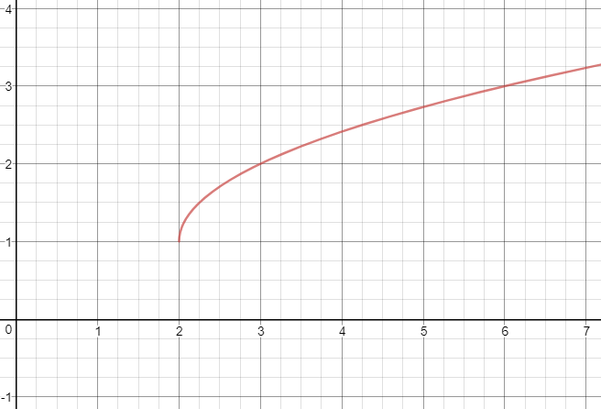
For Questions 13-15, use the following graph.

13. What is the endpoint of the graph?
- (1,2)
- (2,1)
- (-1,-2)
- (-2,-1)

14. What is the domain and range of the graph?
- D: $x≥1$ R: $y≥2$
- D: $x≥ -1$ R: $y≥ -2$
- D: $x≥2$ R: $y≥1$
- D: $x≥ -2$ R: $y≥ -1$

15. What is the equation of the graph?
- $y=\sqrt{x-1}+2$
- $f(x)=\sqrt{x-2}+1$
- $f(x)=\sqrt{x+2}-1$
- $y = \sqrt{x+1}-2$

1.a
2.d
3.d
4.c
5.a
6.c
7.b
8.d
9.b
10.d
11.d
12.a
13.b
14.c
15.b

